Website Traffic (Clickstream) Analysis

Alfido Tech – Executive Summary & Project Document

🔹 Executive Summary
This project analyzes website traffic using clickstream interaction data to understand user behavior, entry and exit patterns, engagement levels, and geographical reach. Due to the absence of session-level and explicit user identifiers, proxy-based analytics techniques were applied, which align with industry-standard practices for clickstream analysis.
The analysis focuses on identifying:
- Key landing interactions (entry points)
- Exit interactions (drop-off points)
- Bounce behavior using single-interaction users
- User engagement trends
- Geographic distribution of traffic
Insights derived from the analysis were used to propose actionable conversion optimization strategies for Alfido Tech. The results highlight that user traffic is concentrated around a limited set of entry points, with a significant proportion of users disengaging after a single interaction. These findings indicate strong opportunities for improving navigation flow, content placement, and call-to-action effectiveness.
Tools Used:
Python (Pandas, Matplotlib, Seaborn), Jupyter Notebook

🔹 Project Resources & Code Links
- Dataset: traffic.csv
- Jupyter Notebook:
https://github.com/sharmasanyam950-dev/Alfrido/tree/main/Website%20Traffic%20Analysis
- Notebook Files:
  - Traffic_cleaning&Analysis.ipynb

🔹 Analysis Workflow (Brief)
- Data loading and cleaning
- Column standardization using proxy identifiers
- KPI computation (total clicks, unique users, engagement)
- Landing interaction analysis (first click per user)
- Exit interaction analysis (last click per user)
- Bounce rate estimation using proxy logic
- Geographic traffic analysis
- Visualization and insights generation

🔹 Key Visualizations (Add Screenshots)
📸 Insert screenshots of the following charts:
- Top 10 Landing Tracks (Bar Chart)
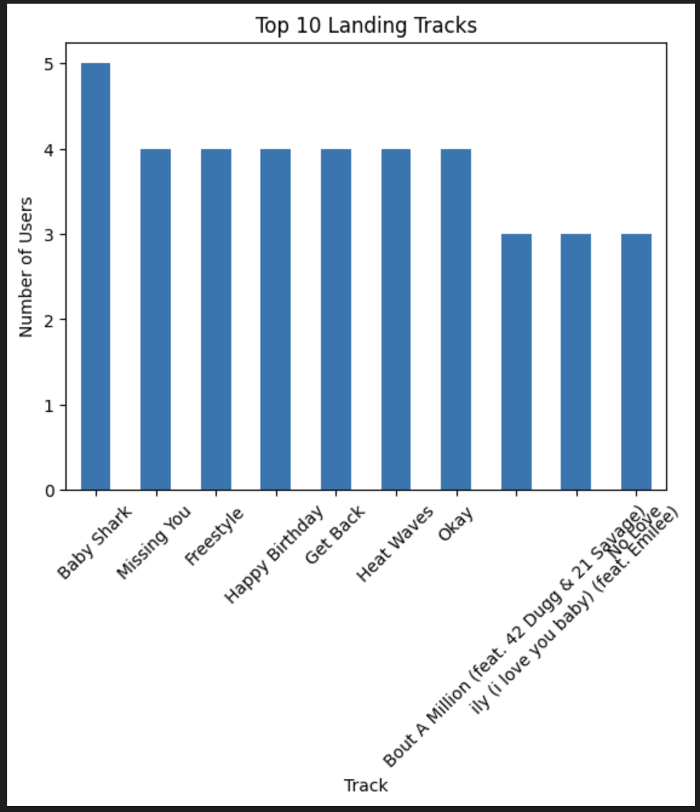

Shows primary entry points for users

- Bounce vs Engaged Users (Bar/Pie Chart)
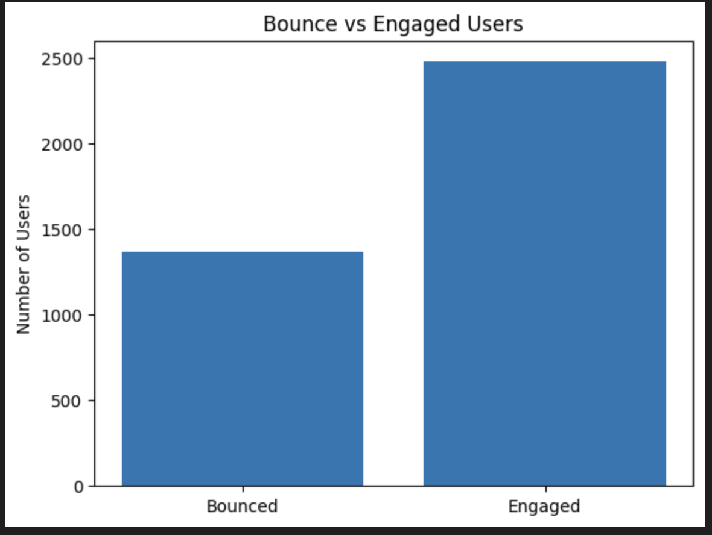
Highlights immediate drop-off behavior
- Top 10 Exit Tracks (Bar Chart)
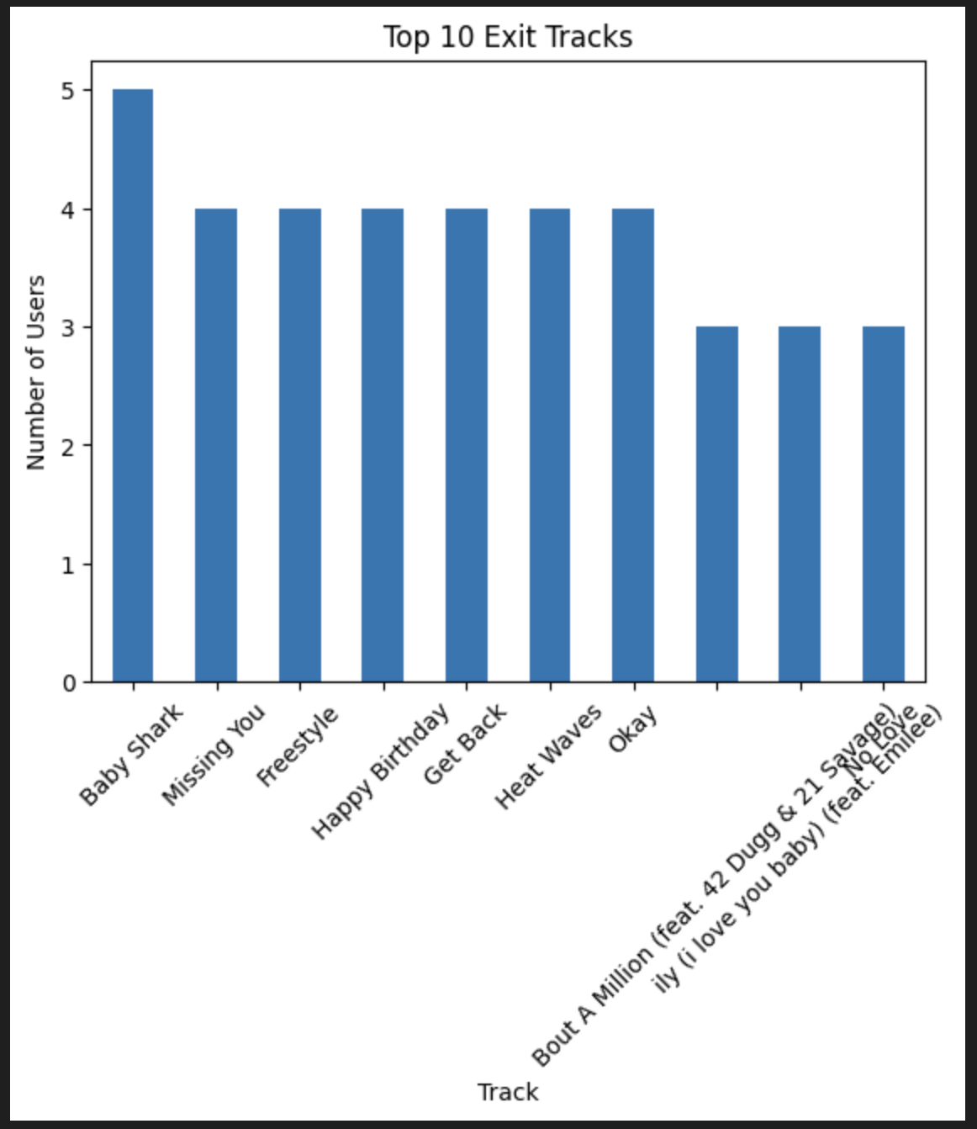
- dentifies disengagement points

- Country-wise Traffic Distribution (Bar Chart)
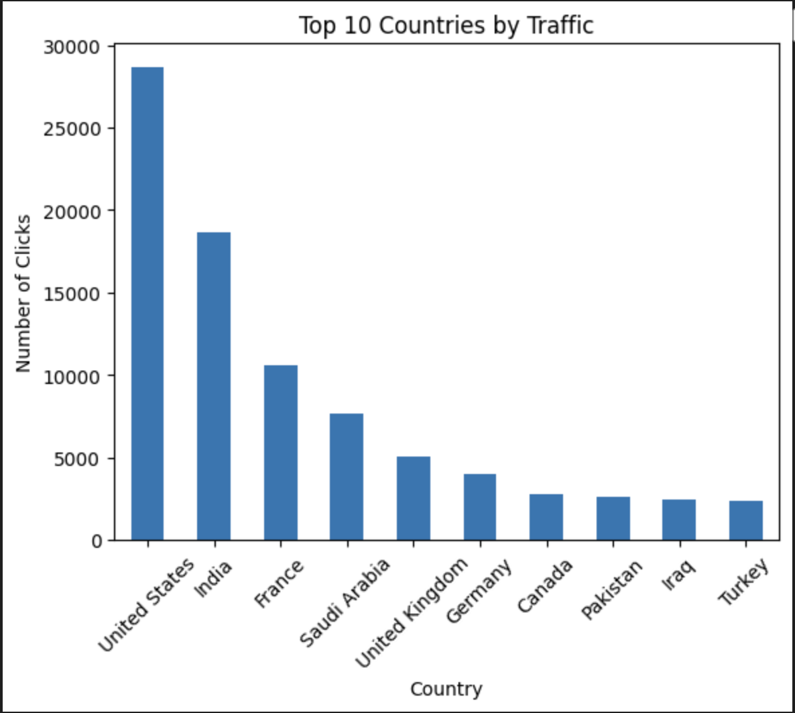
Shows geographic concentration of users

🔹 Key Insights
- User entry traffic is concentrated on a small number of content items.
- A significant portion of users exit after a single interaction, indicating high bounce behavior.
- Certain content consistently appears as exit points, suggesting weak continuation flow.
- Traffic engagement varies by geographic region.
- Limited navigation depth reduces overall conversion potential.

🔹 Recommendations for Alfido Tech
- Optimize high-traffic landing pages with stronger CTAs.
- Reduce bounce rate by improving internal navigation flow.
- Promote high-intent content prominently across the platform.
- Focus marketing efforts on regions with higher engagement.
- Implement session-level tracking for deeper future analysis.

🔹 Conclusion
This project demonstrates how meaningful user behavior insights can be extracted from limited clickstream data using proxy-based analytics techniques. The findings provide clear guidance for improving user engagement and conversion performance at Alfido Tech.

